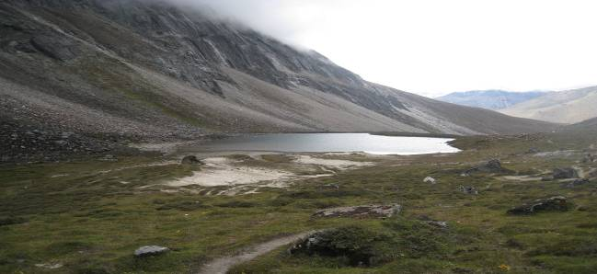
Exotic Holidays

ADVENTURE TOUR TO MUGUTHANG, NORTH SIKKIM

Monalisha Dash, Divisional Forest Officer (Territorial), North Sikkim

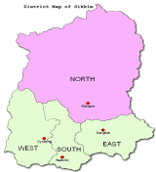
North Sikkim is the largest and beautiful district of Sikkim. The natural beauty of the place is vast and beyond any explanation. North Sikkim is like a stupendous stairway leading from Western Border of the Tibetan Plateau down to the low lying area of Dikchu. Because of its location, it is decorated with the salubrious forest. Thus North Sikkim is endowed with nature’s bounty.

The drive, on 8th September 2008 from Mangan to Muguthang with a team constituting of myself, ACF (T) Mangan, Ms Katherine Lepcha; RO(T) Lachen, Mr. Norden Lepcha; BO (T) Lachen, Mr. Pradeep Subba; FG (T) Thangu, Mr. Sonam Lachenpa DFO (T) ventured as a routine patrolling duty witnessed the mighty untamed River Teesta cascading through mountains and valleys. Series of waterfalls, rivulets join the river to make its volume many fold. As we moved up towards Thangu, we encountered steepest rise in altitude over the shortest distance. Along the river one can feel diverse climatic zones, starting from Tropical to Temperate to Alpine ones. In and around Mangan, the Tropical Forests of Alnus, Terminellia, Michaelia, etc. lead us further to Temperate Forest (around Lachen) of Quercus, Castronopsis, Abies, Tsuga, etc. 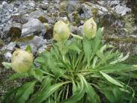Ultimately just below and beyond the Lonak La we came across the Alpine forest of Juniper, Rhododendron, Saxifraga, Susssuria, Rhuem and many more heavenly flowering plants.

Area beyond Thangu falls under the rain shadow of the mighty Himalayas, thus this plateau region does not permit habitation due to unfavourable physiographic and climatic conditions. Except few settlements of Army, ITBP and other para-military organizations, no other human settlement is seen. The complex terrain allows only the trekkers to access the area. The landscape of this area is devoid of big trees, rather rich in medicinal herbs, juniper & rhododendron thickets and many more beautiful alpine flowering herbs. Early morning on 10th September, the group with basic amenities proceeded for Muguthang. From Thangu there is a jeep-able road of approximately 5 km stretch that culminates at Kala Pather. On the left side of the road the spectacular Chopta Valley is viewed. Here the river gracefully meanders to beautify itself. From Kala Pather there is a steep uphill climb of approximately three hours to reach Lugnak –La (18183 feet).
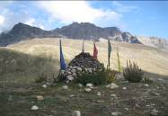The view of Lugnak-La and the adjacent mountains is simply magnificent and breath taking.

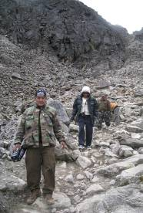The steep downhill view of Muguthang valley from the pass makes speechless. A cautious move can only make an adventurer successful in crossing this. The fear of losing balance and rolling down to unrecoverable gorge gives the thrill. But after successful descend one can feel a sense of confidence in himself. Further as someone proceeds amongst the picturesque serenity, with the vibrancy of the boundless spread of the valley and the lake, one may feel one of the most compelling sites of his lifetime.
Muguthang is a small hamlet on the bank of River Naku Chhu. While venturing the countryside we met one Dokpa named Mr. Nedup Lachenpa. He helped us in getting an insight about the lifestyle of Dokpas at Muguthang. Presently nine families of Dokpas are residing there. They are the nomadic tribes. Mostly the head of the family stays in Muguthang while the children study in Gangtok and other urban areas. Yaks are the fundamental part of their lives. The benefits of products like hard cheese (churpi), meat and butter gives them some earnings. Yak dung is used as fuel for cooking food and fodder and also heating their homes. They also cultivate potatoes and locally called ‘Rai Saag’ for self consumption during the summer times. They then store the potatoes inside pits dug on the ground to consume during winters. When there is scarcity of grass due to snowfall the nettles that grow there are cut, collected and dried during the summer to feed the yaks by mixing it with flour during the winters.

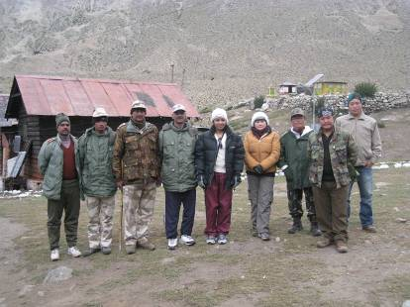
There is an ITBP force deputed at Muguthang to safeguard the International boundary. After reaching Muguthang on 10th of September 2008, around 14:00 hrs we took a round around the ITBP camp. The premise was well maintained but we observed that area lying in-between the ITBP habitation and Dokpas huts was meshed up with garbage thrown here and there by ITBP people for years together. This matter was taken up with the Assistant Commandant (AC) of ITBP posted at Muguthang. In response to the Forest Department’s observation regarding garbage accumulation at Muguthang, AC promptly took action and next day i.e. on 11th of September2008, one Eco-clean Drive were taken up.
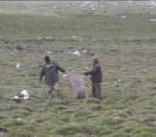
The non- degradable and degradable were segregated. The degradable were put inside the pit and covered for natural decomposition. The non-degradable were put together and asked to transport it back to urban area for recycling.

On 11th of September 2008, after successful completion of Eco-Clean Drive with the help of ITBP, the patrolling group headed back to Thangu crossing through Lugnak-La again. This venture gave us an insight to the awesome topographical as well as biological diversity that makes North Sikkim a treasurer of natural wealth of flora and fauna.

