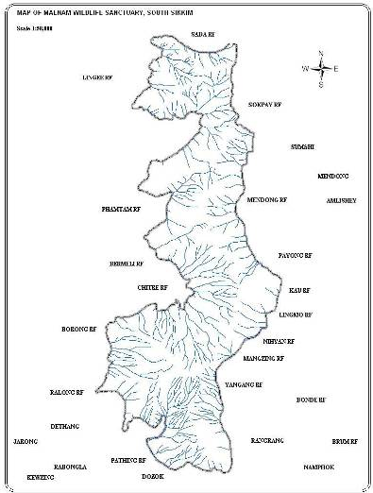
Exotic Holidays

MAENAM WILDLIFE SANCTUARY
- Compiled by ENVIS
Name | Maenam Wildlife Sanctuary
Declaration No | 63/WL/F/86
Declaration Date | 09/03/1987
Area | 35.34 sq. km
Altitude | 2300 m – 3263 m
Nearest Town | Ravangla (2 km)
Road Head | Ravangla
Rail Head | New Jalpaiguri (NJP), West Bengal
Air Port | Bagdogra, West Bengal
Range | Ravangla
Division | South Sikkim
Revenue Sub Division | Ravangla
District | South Sikkim
District HQ | Namchi
Co-ordinates | Longitude 88º 21’to 88º to 25’
Co-ordinates | Latitude 27º 21’ to 27º to 25’

Approach and Access:

The Maenam Wildlife Sanctuary lies in the northern comer of South district. The main entry points being, Ravangla, Lingmoo and Ralang. Tourists generally prefer Ravangla since it is easily approachable by road and private tourist lodges exist. Ravangla is 26 km by road from Namchi, South Sikkim and 65 km from Gangtok via Singtam.

Statement of Significance:

The Maenam Wildlife Sanctuary belongs to the bio-geographical zone 2C (Central Himalayas) as recognized by Rodgers and Panwar, 1988 (Wildlife Institute of India, Dehradun). Major significance of this sanctuary being the number of Schedule I animals it harbors which are given maximum protection in the national level as well as having the main inhabitant in the form of Red Panda and various pheasants.
Some of the animals belonging to schedule I of the Wildlife (Protection) Act, 1972 found in this sanctuary include

1. Red Panda Ailurus fulgens
2. Musk Deer Moschus moschiferus
3. Leopard Panthera pardus
4. Serow Capricomis sumatraensis
5. Chinese Pangolin Manis pentadactyla
6. Goral Naemorhedus goral
7. Satyr Tragopan Tragopan satyra
8. Himalayan Black Bear Selenarctos thibetanus (Schedule II, Part II)
9. Leopard Cat Felis bengalensis
10. Monal Pheasant Lophophorus impejanus
The Sanctuary has tremendous significance for its watershed value, being the only source of perennial water in this ridge. The South District headquarter, Namchi, situated 26 km due South is totally dependent on the piped water originating from the Barmeli stream within the precincts of this sanctuary. The adjoining town of Ravangla is also dependant for potable water on the sanctuary.
There is a historic Buddhist Monastery – Maenam Gumpa, at the top of the ridge, constructed in 1969. There is also a prominent ridge called Bhaleydunga that has a height of 3202m with a drop of almost 5000 feet. The name Bhaley translates to cock in Nepali, and may have gotten its name from the incessant breeding calls of male pheasants perched on this vantage point. People living in the adjoining villages, come to worship Lord Shiva on the top of this rock.

On a clear day, the view of the snow-laden peaks of Mt. Khangchendzonga, Mt. Siniolchu, Mt. Pandim and Mt. Narsing from the ridge top is breath-taking. All the major towns of Sikkim including Siliguri are visible on a clear night.
“Maenam-la” translates to the “Treasure-house of Medicines”, the sanctuary being a rich trove of medicinal plants.

Birds under schedule-I
- Jerdon’s Baza (Aviceda Jerdoni)
- Blood Pheasant (Ithaginis cruentus)
- Crested Goshawk (Accipiter trivirgatus)
- Shikra (Accipiter badius)
- Eurasian sparrow hawk (Accipiter nisus)
- Peregrine Falcon (Falco peregrinus)
- Satyr Tragopan (Tragopan satyra)
- Hill Myna (Gracula religiosa)
- Kalij Pheasant (Lophura leucomelana)

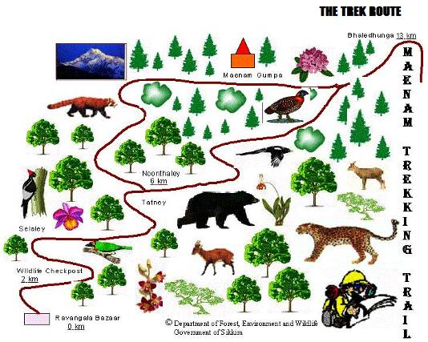
Maenam Wildlife Sanctuary is definitely a treat for the wildlife lovers. Covered by thick forests, Maenam Sanctuary encompasses a vast range of fauna. Apart from its rich fauna, Maenam is famous for being a great trekking destination for trekkers. At a distance of 12 kms, Ravangla is the nearest town to Maenam. The trek route to Maenam starts from Ravangla, transiting through trails of alpine forests in the company of striking vistas of Mt. Kanchenjunga. This trekking expedition takes around 4 hours. On the apex of this sanctuary, one can trace Maenam Monastery. Tourists come to the sanctuary while enjoying the adventure of trekking.

ENTRY PERMIT
[Vide Notification No: 124/KNP/-96/20 Dated 03/05/2001]
Entry permits for visitors can be obtained from the wildlife check post at Ravangla. The rates are as follow::

Indians Rs 25/head/day
Foreigners Rs 50/head/day
Students
Indians Rs 15/head/day
Foreigners Rs 25/head/day
Local Guides and
Porters with the Team Rs 10/head/day
Pack Animals Rs 5/head/day
Tents Pitching Charges Rs 25/tent/day
Still Camera Rs 10/camera/day
Video Camera Rs 500/camera/day
Movie Camera Rs 2000/camera/day

